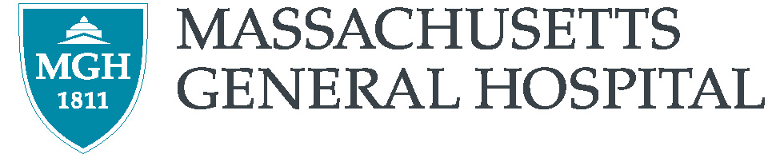

Instructions for Gifts of Securities

to the Massachusetts General Hospital

To transfer securities electronically to the MGH, the DTC instructions are as follows:

Broker Name: UBS Financial Services
DTC Number: 0221
Account Name: MGH

MGH Tax ID #: 04-1564655
Account Number: PWA8289
Send to attention of: Christopher Herlihy
Reference: Donor Name
Phone Number: (617) 439-8028
Fax Number: (855) 330-3561

Please include the donor name in the reference field of the transfer. In addition, in order to properly identify your contribution, notification of your donation must be sent to the MGH Development Office via mail, fax, or email at the address listed below.

In accordance with IRS guidelines, the date of gift will be considered the date that MGH assumes ownership of the shares. For crediting purposes, the value is determined as the average of the high and low listings on the date the stock is gifted.

To donate a physical stock certificate, mail the unendorsed certificate(s) with a letter of instruction that specifies the Massachusetts General Hospital as the recipient and outlines the details of the contribution, as well as any particular designation. Under separate cover, send a copy of this letter and a signed (but otherwise blank) Stock Power form for each certificate, making sure the signature corresponds exactly with the name as it appears on the face of the stock certificate. Mail all documents to the address below. The date of the gift will be determined by the later postmark of the two envelopes. Certificates may also be hand-delivered to the MGH Development Office at the address below. Please note that it is unnecessary to have certificates registered in the Hospital’s name.

To donate mutual fund shares, please contact Chris Herlihy at UBS Financial Services at (617) 439-8028 to initiate the transfer.

If you need clarification or more information regarding the above instructions, please contact:

Gabriel Manchon Telephone: (617) 724-8458
Senior Director, Development Services Facsimile: (617) 726-7661
Massachusetts General Hospital email: gmanchon@partners.org
Development Office
125 Nashua Street, Suite 540
Boston, MA 02114

