**2023 Boston Marathon**

**Injury Prevention Tips**

Many running-related injuries can be prevented or managed with appropriate cross training exercise such as spinning, the elliptical, or aqua jogging, as well as adequate strength training.

The following are general strengthening exercises and stretches to compliment running to keep you in tip-top shape as you train for the marathon. If you need further guidance with injury management during marathon training, contact your physician to see if you may need further medical management or benefit from a referral to Physical Therapy.

A. Draw abdominals in towards spine. Keep rib caged down and in.

B. Push through heels and lift buttocks, avoid arching back. Hold ~5 seconds and slowly lower down.

C. Progression: Push through one heel lifting hips and keeping pelvis level.

3 sets x10 repetitions

A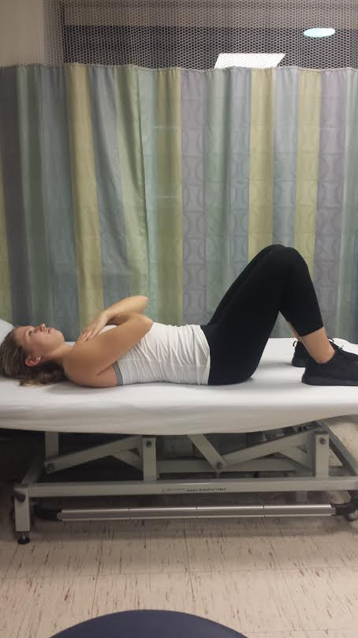 B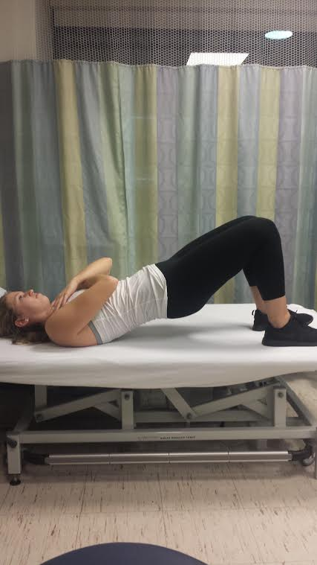C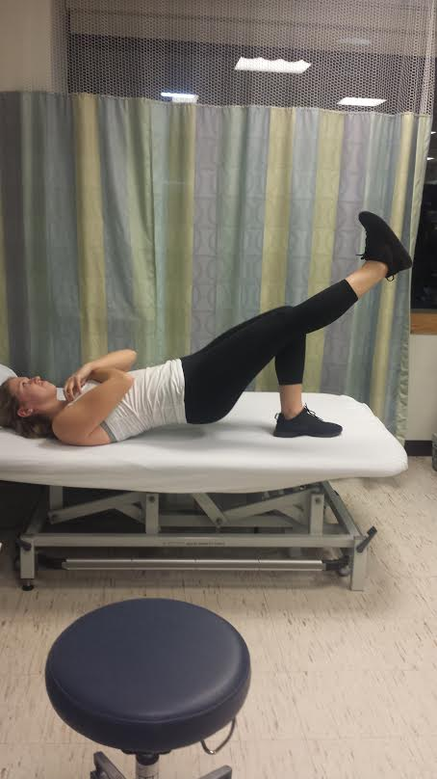

A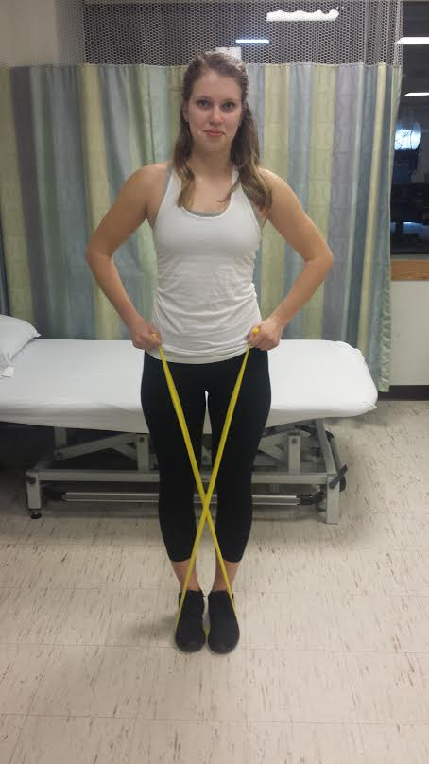 B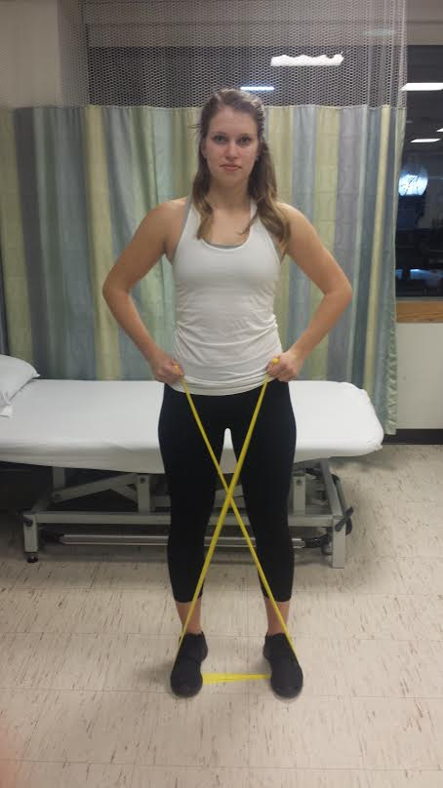

1. Stand with feet together, rib cage over pelvis, abdominals engaged.
2. Push heel out to the side against resistance of band, squeeze buttocks of standing leg and slowly bring in opposite leg to starting position
3. Foot forward on step with abdominals engaged, rib cage over pelvis.
4. Push through heel and squeeze buttocks as you step up, focus on keeping pelvis level
5. Option to bring opposite knee forward and arm on side of standing leg forward to assist in increasing glute activation.

A 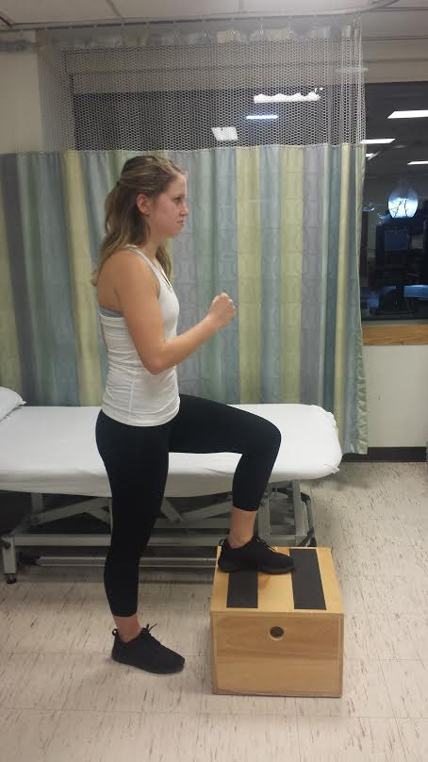 B 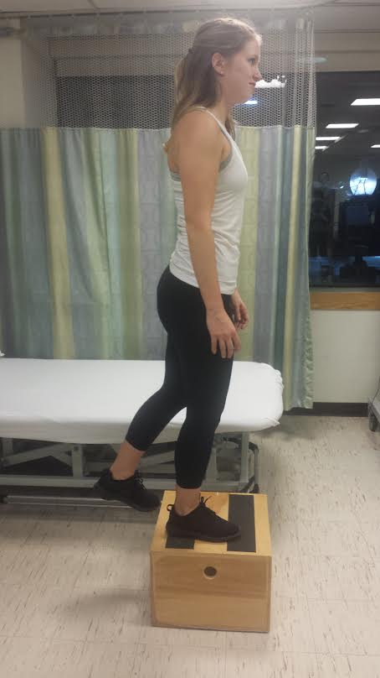 C 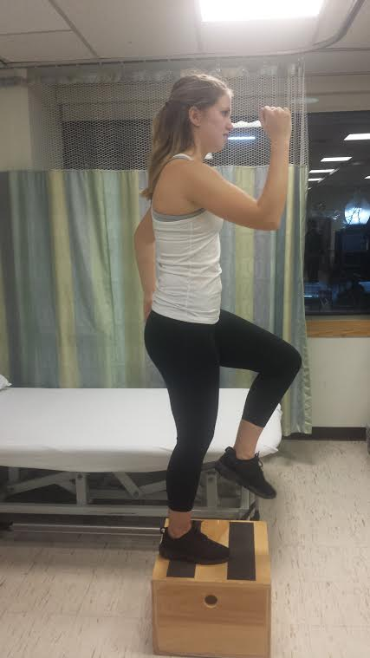

Here are some gentle stretches that may help keep your muscles loose after training runs. Keep in mind they should never increase pain!

A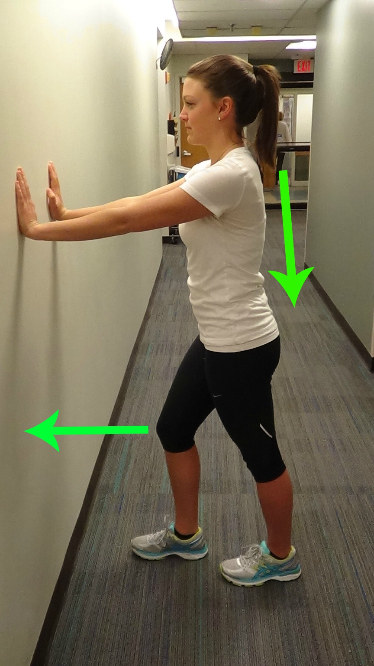 B 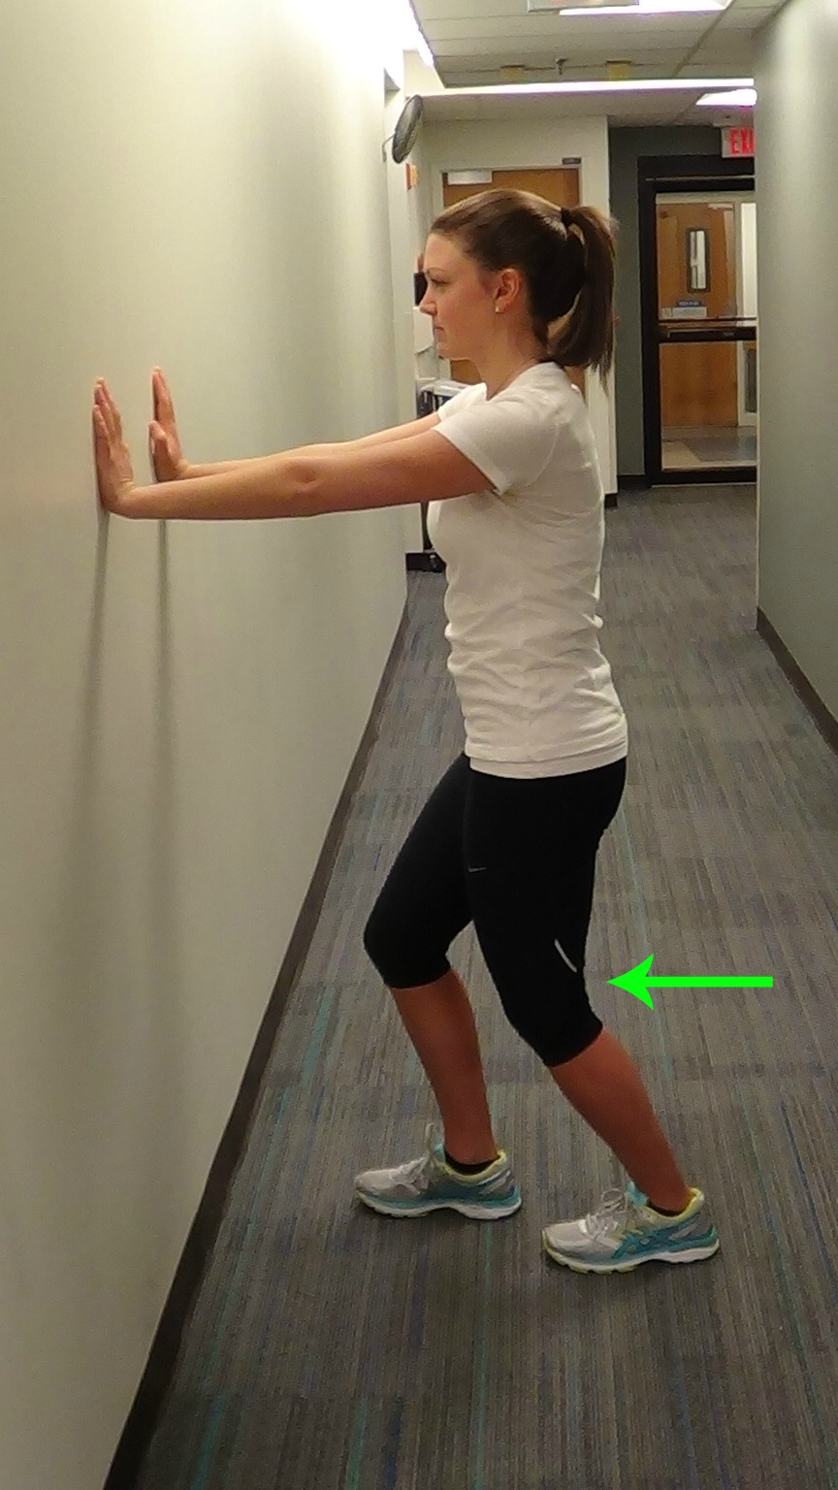

Calf Stretches

A. Heels down, back straight, abdominals tight, relax shoulders and gently lunge forward. Turning your body very slightly left/right can help you emphasize the out-, or inside muscle groups of the calf.

B. Same set up as above but by slightly bending the knee to target the lower part of the calf.

Hamstrings (and Calf) Stretches

C. Lying on the floor with your leg up on the wall. May need to start with the knee slightly bent, and lie further away from the wall initially. By pulling the toes towards you, you include the calf in the stretch.  Turn the leg in/out slightly to access different muscle parts. Bending the opposite leg will minimize any stress to your back if your hip flexor on this side is tight. Pelvis should remain level.

D. In standing, place leg up on step or stool. You may need to start low initially. Back remains straight and pelvis is level. Keep hips square to the front and hinge at your hips to feel the stretch in the hamstrings.  Turn the leg in/out slightly to access different muscles. parts.

C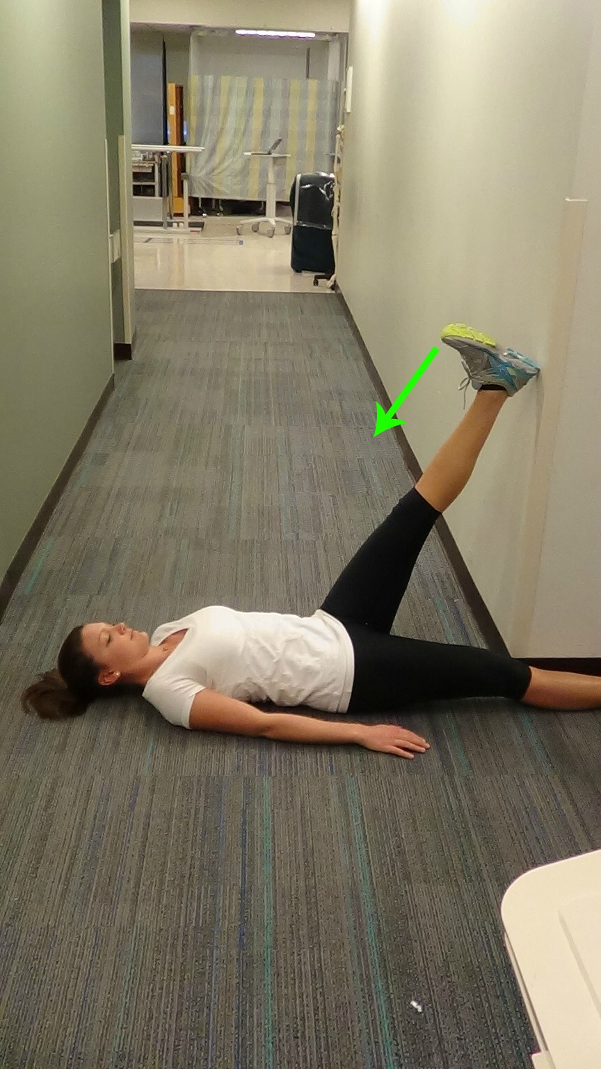 D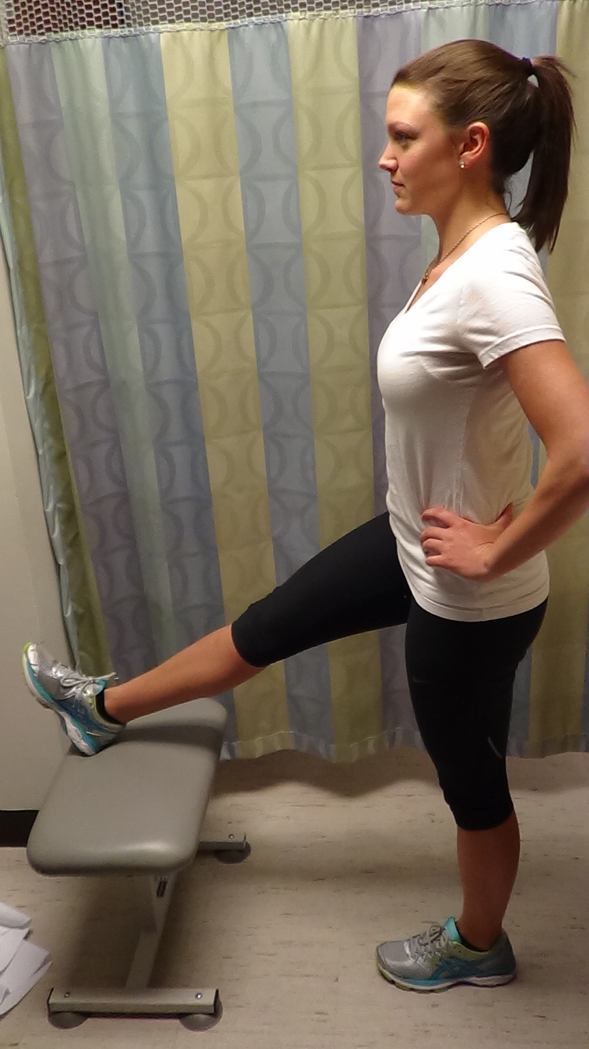

E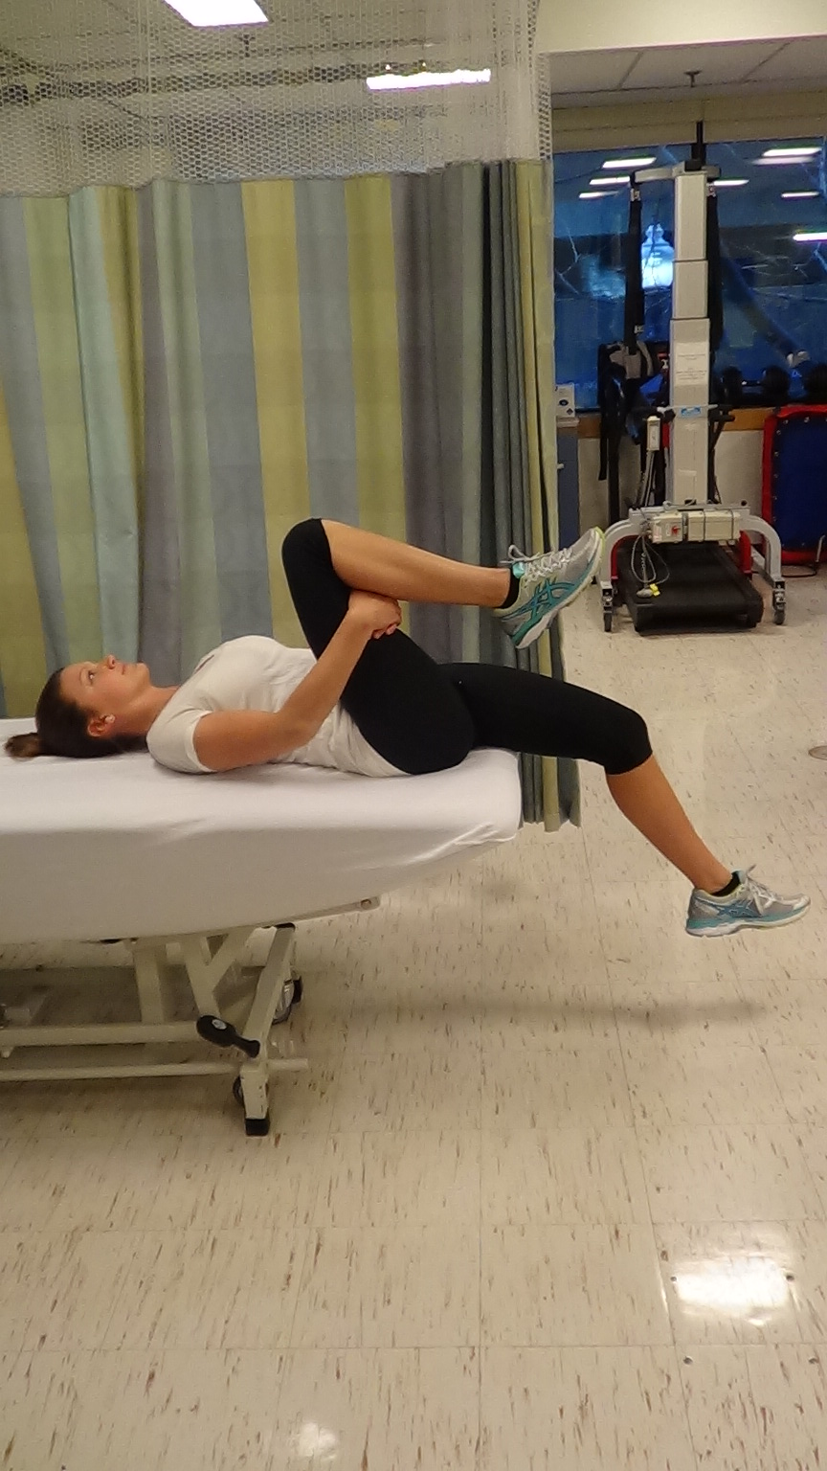 F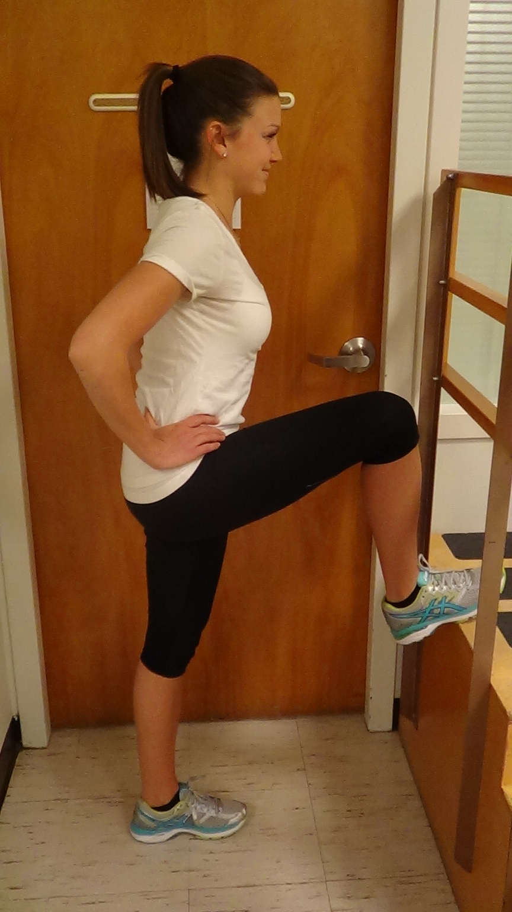

Hip Flexor Stretches

E. Lying flat on a bed pull both knees to chest to flatten your back. Slowly lower one leg over the side of the bed. Gently bend the knee leaving your back and thigh flat to increase the quad stretch. Keep thigh close to midline of your body to include the ITB.

F. Standing one leg up on step or stool. The leg that is straight is being stretched. Back remains straight and pelvis is level. Keep the arch of your loaded foot~ neutral. Lunge forward slightly, and/or raise arm on same side to increase the stretch in the front of your hip.